**SIMPLE NOTIFICATION SERVICE**

**Select Simple Notification Service under Application integration in EC2 dashboard**

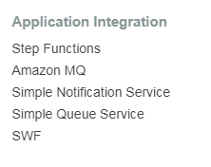

**Click on Get started**

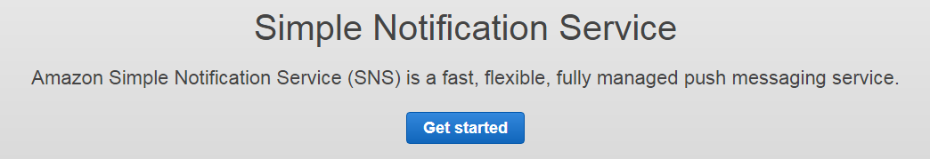

**Under SNS dashboard click on Create topic**

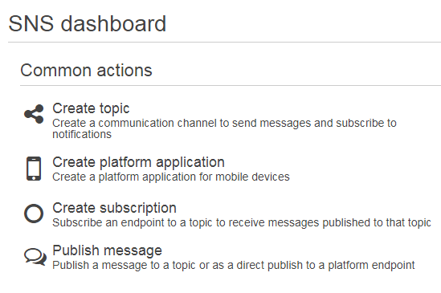

**Give topic name and display name under create new topic**

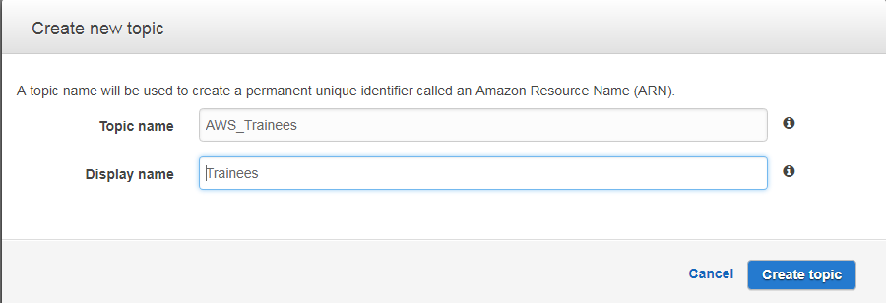

**Topic is now created in the region you have specified.**

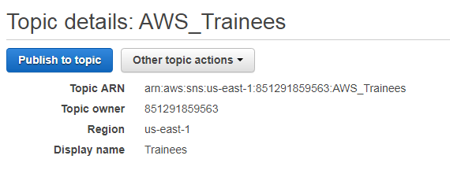

**Under create subscription select protocol as email and give the mail id to whom you need to send a** **message. Click on create subscription**

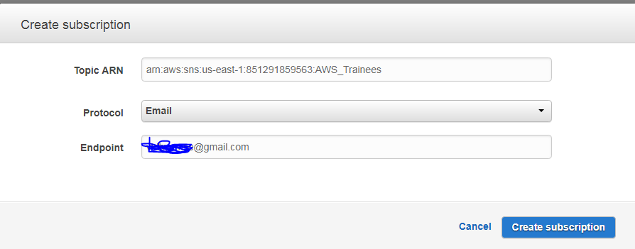

**Subscription is still pending for receiver’s confirmation.**

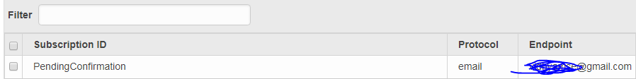

**Click on confirm subscription link .**

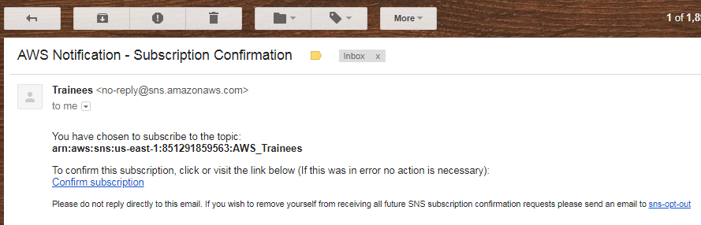

**Your subscription is confirmed**

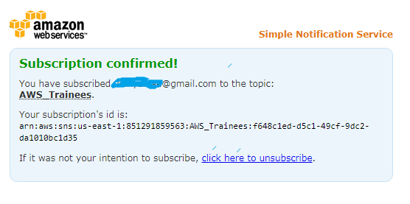

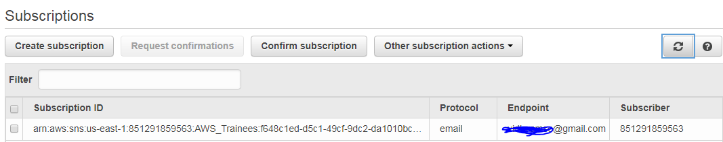

**Under topic details click on publish to topic**

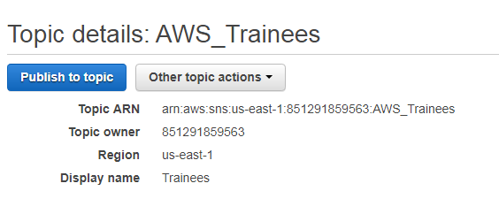

**Write the subject and message for the receiver**

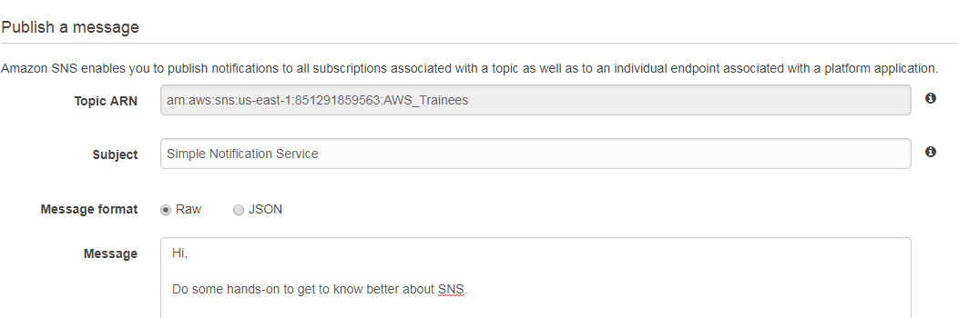

**Your mail is now delivered to the receiver.**

